NAME:S.KAVYA

R.NO:192312393

CODE: ITA0614

COURSE: MACHINE LEARNING

Experiment 3
Demonstrate the working of the decision tree based ID3 algorithm. Use an appropriate data set for building the decision tree and apply this knowledge to classify a new sample.

Basic Concepts
ID3 (Iterative Dichotomiser 3) builds a decision tree top-down. At every node it chooses the attribute that gives the largest information gain, i.e. the attribute that best separates the classes.
Entropy(S) = − Σ p_{i} log₂ p_{i} Gain(S, A) = Entropy(S) − Σ ( |S_{v}| / |S| ) × Entropy(S_{v})
Here pᵢ is the proportion of examples of class i in S, and Sᵥ is the subset of S for which attribute A has value v. A node with entropy 0 is pure and becomes a leaf.

Problem 1 : Play Tennis

Aim
To implement the ID3 algorithm in Python on the classic Play Tennis data set (stored in a list), build the decision tree using entropy and information gain, and classify a new weather sample.

Algorithm
- Create a root node for the training set S.
- If all examples in S belong to one class, return a leaf node labelled with that class.
- If no attributes are left to test, return a leaf labelled with the most common class in S.
- Otherwise compute Entropy(S) and Gain(S, A) for every remaining attribute A, and select the attribute with the highest information gain.
- Make the selected attribute the decision node. For every value v of it, add a branch and repeat steps 2-4 on the subset Sᵥ with that attribute removed.
- To classify a new sample, start at the root, follow the branch matching the sample’s attribute value at each node, and output the label of the leaf reached.

Program:
● ● ● id3_a.py - Python 3
1 # Problem 1: ID3 on the Play Tennis data set (data stored in a list)
2 import math
3 from collections import Counter
4
5 attrs = ['Outlook', 'Temp', 'Humidity', 'Wind']
6 data = [
7 ['Sunny', 'Hot', 'High', 'Weak', 'No'],
8 ['Sunny', 'Hot', 'High', 'Strong', 'No'],
9 ['Overcast', 'Hot', 'High', 'Weak', 'Yes'],
10 ['Rain', 'Mild', 'High', 'Weak', 'Yes'],
11 ['Rain', 'Cool', 'Normal', 'Weak', 'Yes'],
12 ['Rain', 'Cool', 'Normal', 'Strong', 'No'],
13 ['Overcast', 'Cool', 'Normal', 'Strong', 'Yes'],
14 ['Sunny', 'Mild', 'High', 'Weak', 'No'],
15 ['Sunny', 'Cool', 'Normal', 'Weak', 'Yes'],
16 ['Rain', 'Mild', 'Normal', 'Weak', 'Yes'],
17 ['Sunny', 'Mild', 'Normal', 'Strong', 'Yes'],
18 ['Overcast', 'Mild', 'High', 'Strong', 'Yes'],
19 ['Overcast', 'Hot', 'Normal', 'Weak', 'Yes'],
20 ['Rain', 'Mild', 'High', 'Strong', 'No'],
21 ]
22
23 def entropy(rows):
24 n = len(rows)
25 counts = Counter(r[-1] for r in rows)
26 return -sum((c / n) * math.log2(c / n) for c in counts.values())
27
28 def gain(rows, i):
29 n = len(rows)
30 rem = 0
31 for v in set(r[i] for r in rows):
32 sub = [r for r in rows if r[i] == v]
33 rem += len(sub) / n * entropy(sub)
34 return entropy(rows) - rem
35
36 def id3(rows, avail):
37 labels = [r[-1] for r in rows]
38 if len(set(labels)) == 1:
39 return labels[0]
40 if not avail:
41 return Counter(labels).most_common(1)[0][0]
42 best = max(avail, key=lambda i: gain(rows, i))
43 tree = {attrs[best]: {}}
44 for v in sorted(set(r[best] for r in rows)):
45 sub = [r for r in rows if r[best] == v]
46 tree[attrs[best]][v] = id3(sub, [a for a in avail if a != best])
47 return tree
48
49 def show(tree, indent=0):
50 if not isinstance(tree, dict):
51 return
52 attr = next(iter(tree))
53 for v, sub in tree[attr].items():
54 if isinstance(sub, dict):
55 print(" " * indent + f"{attr} = {v}:")
56 show(sub, indent + 1)
57 else:
58 print(" " * indent + f"{attr} = {v} -> {sub}")
59
60 def classify(tree, sample):
61 while isinstance(tree, dict):
62 attr = next(iter(tree))
63 tree = tree[attr][sample[attr]]
64 return tree
65
66 print("Entropy of the full data set : %.4f" % entropy(data))
67 print("-" * 44)
68 for i, a in enumerate(attrs):
69 print(f"Information Gain({a:8s}) = {gain(data, i):.4f}")
70 print("-" * 44)
71
72 tree = id3(data, list(range(len(attrs))))
73 print("Decision tree learned by ID3:")
74 show(tree)
75
76 new = {'Outlook': 'Sunny', 'Temp': 'Cool', 'Humidity': 'High', 'Wind': 'Strong'}
77 print("-" * 44)
78 print("New sample :", new)
79 print("Prediction : PlayTennis =", classify(tree, new))
80

Input
Play Tennis data set: 14 training examples, 4 attributes (Outlook, Temp, Humidity, Wind) and the target concept PlayTennis (Yes / No). The data is hard-coded in the program as a list of lists. New sample to classify: <Sunny, Cool, High, Strong>.
Outlook | Temp | Humidity | Wind | PlayTennis
Sunny | Hot | High | Weak | No
Sunny | Hot | High | Strong | No
Overcast | Hot | High | Weak | Yes
Rain | Mild | High | Weak | Yes
Rain | Cool | Normal | Weak | Yes
Rain | Cool | Normal | Strong | No
Overcast | Cool | Normal | Strong | Yes
Sunny | Mild | High | Weak | No
Sunny | Cool | Normal | Weak | Yes
Rain | Mild | Normal | Weak | Yes
Sunny | Mild | Normal | Strong | Yes
Overcast | Mild | High | Strong | Yes
Overcast | Hot | Normal | Weak | Yes
Rain | Mild | High | Strong | No

Output
● ● ● Terminal - Output
$ python id3_a.py
Entropy of the full data set : 0.9403
--------------------------------------------
Information Gain(Outlook ) = 0.2467
Information Gain(Temp ) = 0.0292
Information Gain(Humidity) = 0.1518
Information Gain(Wind ) = 0.0481
--------------------------------------------
Decision tree learned by ID3:
Outlook = Overcast -> Yes
Outlook = Rain:
Wind = Strong -> No
Wind = Weak -> Yes
Outlook = Sunny:
Humidity = High -> No
Humidity = Normal -> Yes
--------------------------------------------
New sample : {'Outlook': 'Sunny', 'Temp': 'Cool', 'Humidity': 'High', 'Wind': 'Strong'}
Prediction : PlayTennis = No
$ _

Decision Tree
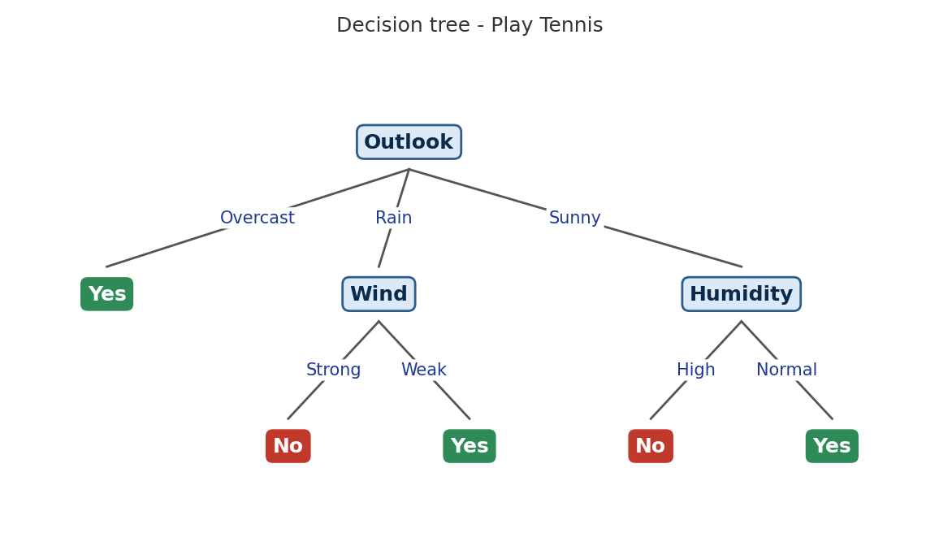

Result
The ID3 algorithm was implemented and executed successfully. Outlook has the highest information gain (0.2467), so it becomes the root; Overcast gives a pure “Yes”, Sunny is split on Humidity and Rain is split on Wind. The new sample <Sunny, Cool, High, Strong> follows Outlook = Sunny → Humidity = High and is classified as PlayTennis = No.

Problem 2 : Loan Approval

Aim
To implement ID3 by reading loan application records from a .CSV file with the csv module and storing the tree as Node objects, and to predict whether a new application will be approved.

Algorithm
- Create a root node for the training set S.
- If all examples in S belong to one class, return a leaf node labelled with that class.
- If no attributes are left to test, return a leaf labelled with the most common class in S.
- Otherwise compute Entropy(S) and Gain(S, A) for every remaining attribute A, and select the attribute with the highest information gain.
- Make the selected attribute the decision node. For every value v of it, add a branch and repeat steps 2-4 on the subset Sᵥ with that attribute removed.
- To classify a new sample, start at the root, follow the branch matching the sample’s attribute value at each node, and output the label of the leaf reached.

Program:
● ● ● id3_b.py - Python 3
1 # Problem 2: ID3 using the csv module and a Node class (Loan Approval)
2 import csv, math
3 from collections import Counter
4
5 class Node:
6 def __init__(self, attr=None, label=None):
7 self.attr, self.label, self.children = attr, label, {}
8
9 def entropy(rows):
10 n = len(rows)
11 return -sum(c / n * math.log2(c / n) for c in Counter(r[-1] for r in rows).values())
12
13 def gain(rows, i):
14 rem = sum(len(s) / len(rows) * entropy(s)
15 for s in ([r for r in rows if r[i] == v] for v in set(r[i] for r in rows)))
16 return entropy(rows) - rem
17
18 def build(rows, avail, header):
19 labels = [r[-1] for r in rows]
20 if len(set(labels)) == 1:
21 return Node(label=labels[0])
22 if not avail:
23 return Node(label=Counter(labels).most_common(1)[0][0])
24 best = max(avail, key=lambda i: gain(rows, i))
25 node = Node(attr=best)
26 for v in sorted(set(r[best] for r in rows)):
27 node.children[v] = build([r for r in rows if r[best] == v],
28 [a for a in avail if a != best], header)
29 return node
30
31 def display(node, header, depth=0):
32 if node.label is not None:
33 print(" " * depth + "=> " + node.label)
34 return
35 for v, child in node.children.items():
36 print(" " * depth + f"[{header[node.attr]} = {v}]")
37 display(child, header, depth + 1)
38
39 def predict(node, sample):
40 while node.label is None:
41 node = node.children[sample[node.attr]]
42 return node.label
43
44 with open('loan.csv') as f:
45 reader = csv.reader(f)
46 header = next(reader)
47 rows = [r for r in reader]
48
49 print("Attributes :", header[:-1])
50 print("Target :", header[-1], "| samples =", len(rows))
51 print("Root entropy = %.4f" % entropy(rows))
52 for i in range(len(header) - 1):
53 print(f" Gain({header[i]}) = {gain(rows, i):.4f}")
54
55 root = build(rows, list(range(len(header) - 1)), header)
56 print("\nDecision tree:")
57 display(root, header)
58
59 new = ['Medium', 'Good', 'Employed', 'High'] # Income, Credit, Job, Amount
60 print("\nNew sample :", dict(zip(header, new)))
61 print("Prediction : Approve =", predict(root, new))
62

Input
Loan Approval data set (loan.csv): 12 examples, 4 attributes (Income, Credit, Job, Amount) and the target concept Approve (Yes / No). The first row of the file holds the attribute names. New sample to classify: <Medium, Good, Employed, High>.
Income | Credit | Job | Amount | Approve
High | Good | Employed | Low | Yes
High | Bad | Employed | High | No
Medium | Good | Employed | Low | Yes
Low | Good | Unemployed | Low | No
Low | Bad | Unemployed | High | No
Medium | Good | Unemployed | High | Yes
High | Good | Unemployed | High | Yes
Low | Bad | Employed | Low | No
Medium | Bad | Employed | Low | No
High | Good | Employed | High | Yes
Low | Good | Employed | High | Yes
Medium | Bad | Unemployed | High | No

Output
● ● ● Terminal - Output
$ python id3_b.py
Attributes : ['Income', 'Credit', 'Job', 'Amount']
Target : Approve | samples = 12
Root entropy = 1.0000
Gain(Income) = 0.1258
Gain(Credit) = 0.6549
Gain(Job) = 0.0207
Gain(Amount) = 0.0207

Decision tree:
[Credit = Bad]
=> No
[Credit = Good]
[Income = High]
=> Yes
[Income = Low]
[Job = Employed]
=> Yes
[Job = Unemployed]
=> No
[Income = Medium]
=> Yes

New sample : {'Income': 'Medium', 'Credit': 'Good', 'Job': 'Employed', 'Amount': 'High'}
Prediction : Approve = Yes
$ _

Decision Tree
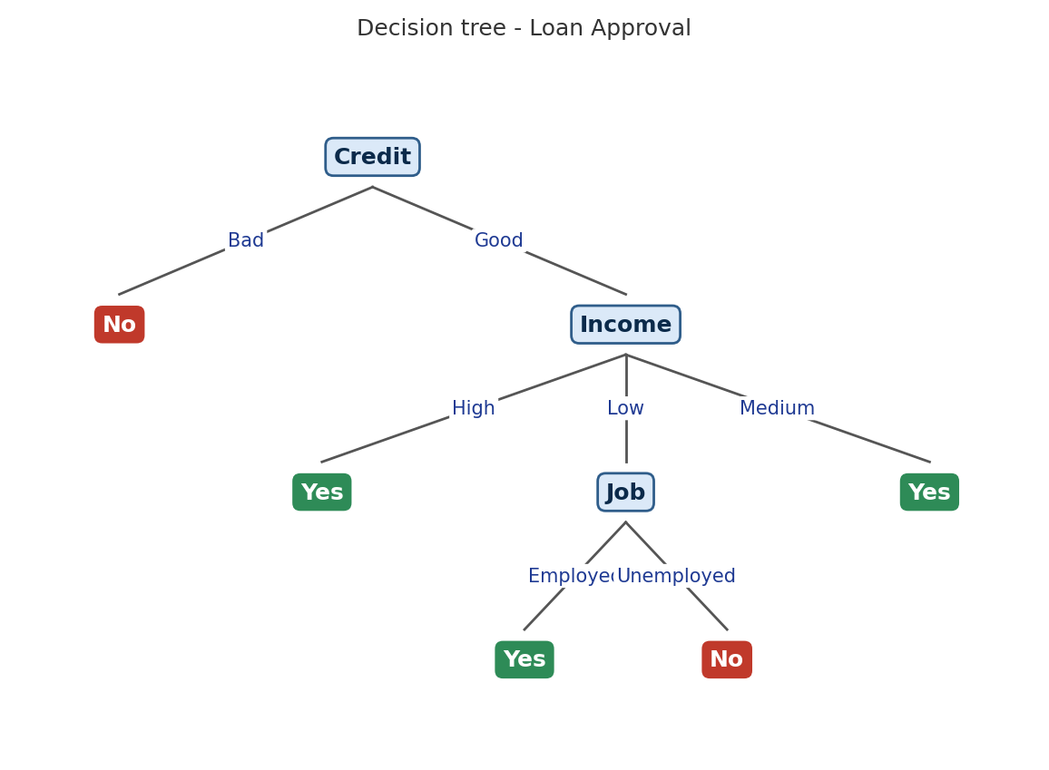

Result
The decision tree was built from the CSV data. Credit has the highest gain (0.6549) and is the root: every applicant with Bad credit is rejected, while applicants with Good credit are decided by Income and, for Low income, by Job. The new application <Medium, Good, Employed, High> is classified as Approve = Yes.

Problem 3 : Flu Diagnosis

Aim
To implement ID3 using pandas DataFrame operations (groupby and value_counts) and use the resulting tree to diagnose flu for new patients.

Algorithm
- Create a root node for the training set S.
- If all examples in S belong to one class, return a leaf node labelled with that class.
- If no attributes are left to test, return a leaf labelled with the most common class in S.
- Otherwise compute Entropy(S) and Gain(S, A) for every remaining attribute A, and select the attribute with the highest information gain.
- Make the selected attribute the decision node. For every value v of it, add a branch and repeat steps 2-4 on the subset Sᵥ with that attribute removed.
- To classify a new sample, start at the root, follow the branch matching the sample’s attribute value at each node, and output the label of the leaf reached.

Program:
● ● ● id3_c.py - Python 3
1 # Problem 3: ID3 using pandas DataFrame operations (Flu Diagnosis)
2 import pandas as pd
3 import numpy as np
4
5 def entropy(col):
6 p = col.value_counts(normalize=True)
7 return float(-(p * np.log2(p)).sum())
8
9 def info_gain(df, attr, target):
10 rem = sum(len(g) / len(df) * entropy(g[target]) for _, g in df.groupby(attr))
11 return entropy(df[target]) - rem
12
13 def id3(df, target, features):
14 if df[target].nunique() == 1:
15 return df[target].iloc[0]
16 if not features:
17 return df[target].mode()[0]
18 best = max(features, key=lambda a: info_gain(df, a, target))
19 rest = [f for f in features if f != best]
20 return {best: {v: id3(g, target, rest) for v, g in df.groupby(best)}}
21
22 def print_tree(t, depth=0):
23 if not isinstance(t, dict):
24 return
25 a = next(iter(t))
26 for v, sub in t[a].items():
27 leaf = "" if isinstance(sub, dict) else f" -> {sub}"
28 print(" " * depth + f"{a} = {v}{leaf}")
29 print_tree(sub, depth + 1)
30
31 def predict(t, s):
32 while isinstance(t, dict):
33 a = next(iter(t))
34 t = t[a][s[a]]
35 return t
36
37 df = pd.read_csv('flu.csv')
38 target, features = 'Flu', list(df.columns[:-1])
39 print("Training data :", df.shape[0], "rows,", len(features), "attributes")
40 print("Entropy(Flu) : %.4f" % entropy(df[target]))
41 print("\nInformation gain at the root:")
42 for f in features:
43 print(f" {f:9s}: {info_gain(df, f, target):.4f}")
44
45 tree = id3(df, target, features)
46 print("\nDecision tree:")
47 print_tree(tree)
48
49 tests = [
50 {'Fever': 'Yes', 'Cough': 'No', 'Fatigue': 'Yes', 'BodyAche': 'No'},
51 {'Fever': 'No', 'Cough': 'Yes', 'Fatigue': 'No', 'BodyAche': 'Yes'},
52 ]
53 print("\nClassifying new samples:")
54 for s in tests:
55 print(" ", list(s.values()), "->", predict(tree, s))
56

Input
Flu Diagnosis data set (flu.csv): 12 examples, 4 attributes (Fever, Cough, Fatigue, BodyAche) and the target concept Flu (Yes / No), loaded into a pandas DataFrame. New samples: <Yes, No, Yes, No> and <No, Yes, No, Yes>.
Fever | Cough | Fatigue | BodyAche | Flu
Yes | Yes | Yes | Yes | Yes
Yes | Yes | No | Yes | Yes
No | Yes | No | No | No
Yes | No | Yes | Yes | Yes
No | No | No | No | No
Yes | Yes | No | No | No
No | Yes | Yes | Yes | Yes
No | No | Yes | No | No
Yes | No | No | Yes | Yes
No | Yes | No | Yes | No
Yes | Yes | Yes | No | No
No | No | Yes | Yes | Yes

Output
● ● ● Terminal - Output
$ python id3_c.py
Training data : 12 rows, 4 attributes
Entropy(Flu) : 1.0000

Information gain at the root:
Fever : 0.0817
Cough : 0.0207
Fatigue : 0.0817
BodyAche : 0.6549

Decision tree:
BodyAche = No -> No
BodyAche = Yes
Fever = No
Fatigue = No -> No
Fatigue = Yes -> Yes
Fever = Yes -> Yes

Classifying new samples:
['Yes', 'No', 'Yes', 'No'] -> No
['No', 'Yes', 'No', 'Yes'] -> No
$ _

Decision Tree
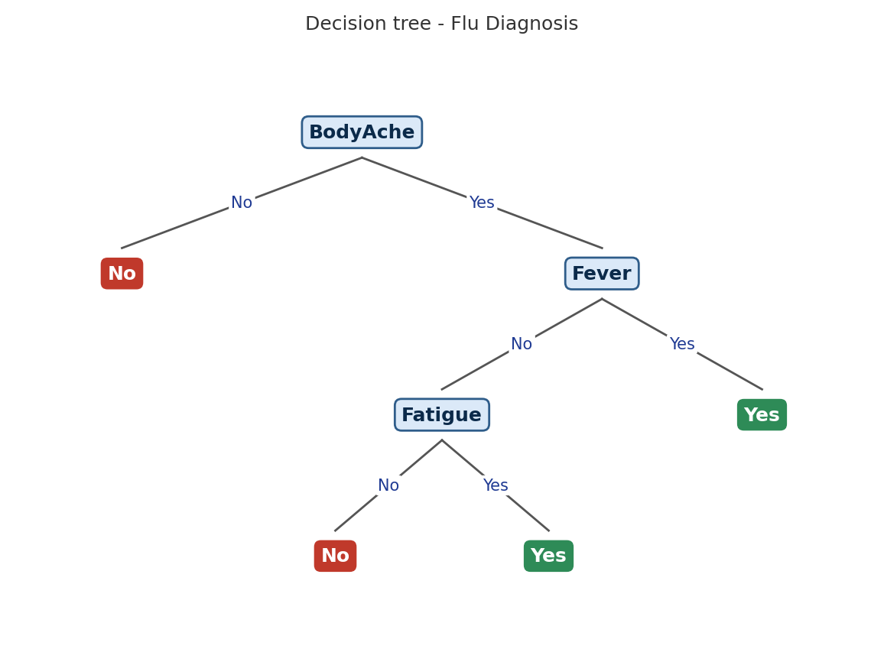

Result
ID3 was implemented with pandas. BodyAche has the highest gain (0.6549) and is the root; when BodyAche = Yes the tree tests Fever and then Fatigue. Both new patients are classified as Flu = No: the first because BodyAche = No, the second because Fever = No and Fatigue = No.

Problem 4 : Spam Email

Aim
To implement ID3 using user-defined functions, print the split chosen at each level, convert the tree into IF-THEN rules and use it to classify new emails with an accuracy check.

Algorithm
- Create a root node for the training set S.
- If all examples in S belong to one class, return a leaf node labelled with that class.
- If no attributes are left to test, return a leaf labelled with the most common class in S.
- Otherwise compute Entropy(S) and Gain(S, A) for every remaining attribute A, and select the attribute with the highest information gain.
- Make the selected attribute the decision node. For every value v of it, add a branch and repeat steps 2-4 on the subset Sᵥ with that attribute removed.
- To classify a new sample, start at the root, follow the branch matching the sample’s attribute value at each node, and output the label of the leaf reached.

Program:
● ● ● id3_d.py - Python 3
1 # Problem 4: ID3 with user-defined functions, IF-THEN rules and accuracy (Spam Email)
2 import math
3 from collections import Counter
4
5 features = ['HasLink', 'Sender', 'HasOffer', 'AllCaps']
6 train = [
7 ('Yes', 'Unknown', 'Yes', 'Yes', 'Spam'),
8 ('Yes', 'Unknown', 'Yes', 'No', 'Spam'),
9 ('No', 'Known', 'No', 'No', 'Ham'),
10 ('Yes', 'Unknown', 'No', 'Yes', 'Spam'),
11 ('Yes', 'Known', 'No', 'No', 'Ham'),
12 ('No', 'Unknown', 'Yes', 'No', 'Spam'),
13 ('No', 'Known', 'Yes', 'No', 'Ham'),
14 ('Yes', 'Known', 'Yes', 'Yes', 'Spam'),
15 ('No', 'Known', 'No', 'Yes', 'Ham'),
16 ('No', 'Unknown', 'No', 'No', 'Ham'),
17 ]
18
19 def entropy(rows):
20 n = len(rows)
21 return -sum(c / n * math.log2(c / n) for c in Counter(r[-1] for r in rows).values())
22
23 def gain(rows, i):
24 total = 0
25 for v in set(r[i] for r in rows):
26 sub = [r for r in rows if r[i] == v]
27 total += len(sub) / len(rows) * entropy(sub)
28 return entropy(rows) - total
29
30 def build(rows, avail, level=0):
31 labels = [r[-1] for r in rows]
32 if len(set(labels)) == 1:
33 return labels[0]
34 if not avail:
35 return Counter(labels).most_common(1)[0][0]
36 gains = {i: gain(rows, i) for i in avail}
37 best = max(gains, key=gains.get)
38 pad = ' ' * level
39 print(f"{pad}Split on {features[best]} "
40 f"(gain = {gains[best]:.4f}, entropy = {entropy(rows):.4f})")
41 node = (best, {})
42 for v in sorted(set(r[best] for r in rows)):
43 sub = [r for r in rows if r[best] == v]
44 node[1][v] = build(sub, [a for a in avail if a != best], level + 1)
45 return node
46
47 def rules(node, path=()):
48 if isinstance(node, str):
49 print("IF " + " AND ".join(path) + f" THEN Class = {node}")
50 return
51 i, branches = node
52 for v, sub in branches.items():
53 rules(sub, path + (f"{features[i]} = {v}",))
54
55 def predict(node, row):
56 while not isinstance(node, str):
57 node = node[1][row[node[0]]]
58 return node
59
60 tree = build(train, list(range(4)))
61 print("\nRules extracted from the tree:")
62 rules(tree)
63
64 tests = [('Yes', 'Unknown', 'No', 'No', 'Spam'),
65 ('No', 'Known', 'Yes', 'Yes', 'Ham'),
66 ('Yes', 'Known', 'Yes', 'No', 'Spam')]
67 print("\nNew emails (HasLink, Sender, HasOffer, AllCaps):")
68 ok = 0
69 for t in tests:
70 p = predict(tree, t[:-1])
71 ok += (p == t[-1])
72 print(" ", t[:-1], "-> predicted:", p, "| actual:", t[-1])
73 print("Accuracy on test emails : %d/%d" % (ok, len(tests)))
74

Input
Spam Email data set: 10 examples, 4 attributes (HasLink, Sender, HasOffer, AllCaps) and the target concept Class (Spam / Ham). The data is stored in the program. Three new emails are used for testing.
HasLink | Sender | HasOffer | AllCaps | Class
Yes | Unknown | Yes | Yes | Spam
Yes | Unknown | Yes | No | Spam
No | Known | No | No | Ham
Yes | Unknown | No | Yes | Spam
Yes | Known | No | No | Ham
No | Unknown | Yes | No | Spam
No | Known | Yes | No | Ham
Yes | Known | Yes | Yes | Spam
No | Known | No | Yes | Ham
No | Unknown | No | No | Ham

Output
● ● ● Terminal - Output
$ python id3_d.py
Split on HasLink (gain = 0.2781, entropy = 1.0000)
Split on Sender (gain = 0.3219, entropy = 0.7219)
Split on HasOffer (gain = 1.0000, entropy = 1.0000)
Split on Sender (gain = 0.3219, entropy = 0.7219)
Split on HasOffer (gain = 1.0000, entropy = 1.0000)

Rules extracted from the tree:
IF HasLink = No AND Sender = Known THEN Class = Ham
IF HasLink = No AND Sender = Unknown AND HasOffer = No THEN Class = Ham
IF HasLink = No AND Sender = Unknown AND HasOffer = Yes THEN Class = Spam
IF HasLink = Yes AND Sender = Known AND HasOffer = No THEN Class = Ham
IF HasLink = Yes AND Sender = Known AND HasOffer = Yes THEN Class = Spam
IF HasLink = Yes AND Sender = Unknown THEN Class = Spam

New emails (HasLink, Sender, HasOffer, AllCaps):
('Yes', 'Unknown', 'No', 'No') -> predicted: Spam | actual: Spam
('No', 'Known', 'Yes', 'Yes') -> predicted: Ham | actual: Ham
('Yes', 'Known', 'Yes', 'No') -> predicted: Spam | actual: Spam
Accuracy on test emails : 3/3
$ _

Decision Tree
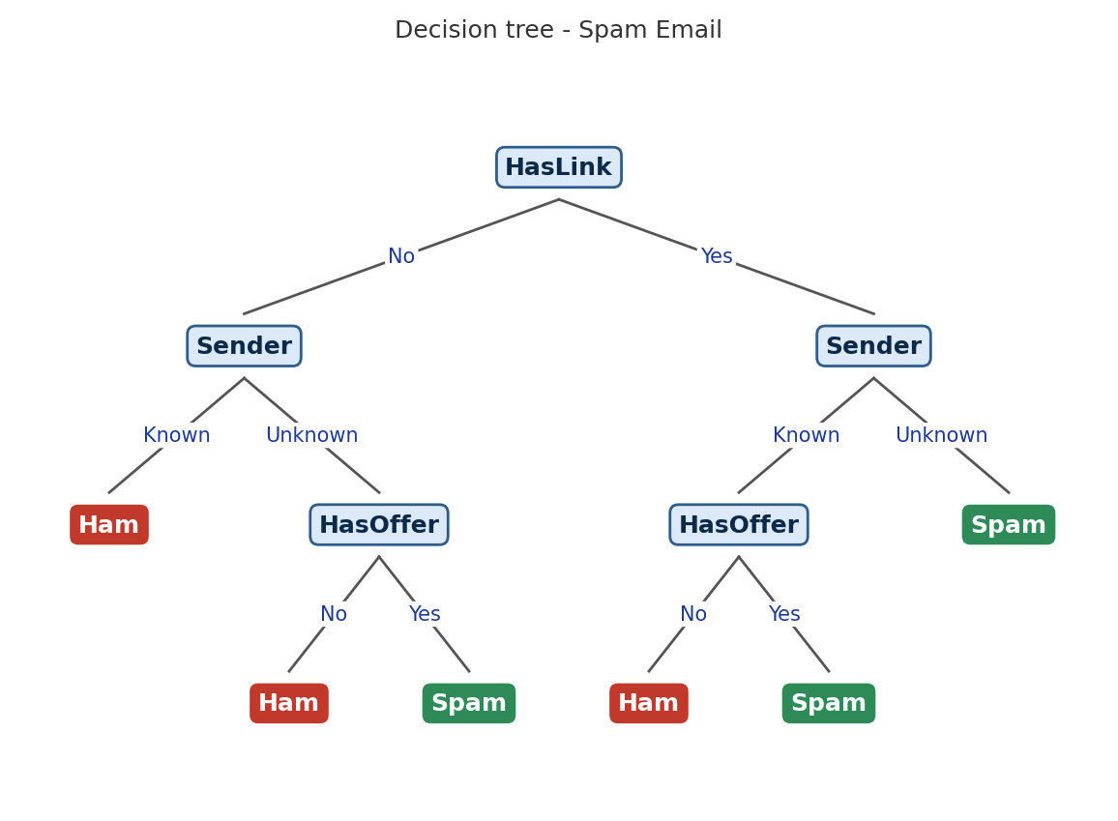

Result
The tree splits on HasLink first (gain 0.2781), then on Sender, and finally on HasOffer; AllCaps is never needed. Six IF-THEN rules were extracted, and all three new emails were classified correctly (accuracy 3/3).

Problem 5 : Job Selection

Aim
To implement ID3 using NumPy arrays (np.unique and boolean masks) on the job selection data and decide whether a new candidate is selected.

Algorithm
- Create a root node for the training set S.
- If all examples in S belong to one class, return a leaf node labelled with that class.
- If no attributes are left to test, return a leaf labelled with the most common class in S.
- Otherwise compute Entropy(S) and Gain(S, A) for every remaining attribute A, and select the attribute with the highest information gain.
- Make the selected attribute the decision node. For every value v of it, add a branch and repeat steps 2-4 on the subset Sᵥ with that attribute removed.
- To classify a new sample, start at the root, follow the branch matching the sample’s attribute value at each node, and output the label of the leaf reached.

Program:
● ● ● id3_e.py - Python 3
1 # Problem 5: ID3 using NumPy arrays (Job Selection)
2 import numpy as np
3
4 cols = ['Degree', 'Experience', 'Interview', 'Skills']
5 X = np.array([
6 ['BTech', 'Yes', 'Good', 'High'],
7 ['BTech', 'Yes', 'Poor', 'High'],
8 ['MTech', 'No', 'Good', 'High'],
9 ['BSc', 'No', 'Poor', 'Low'],
10 ['MTech', 'Yes', 'Good', 'Low'],
11 ['BSc', 'Yes', 'Poor', 'Low'],
12 ['BTech', 'No', 'Good', 'Low'],
13 ['MTech', 'Yes', 'Poor', 'High'],
14 ['BSc', 'No', 'Good', 'High'],
15 ['BTech', 'No', 'Poor', 'Low'],
16 ])
17 y = np.array(['Yes', 'No', 'Yes', 'No', 'Yes', 'No', 'No', 'Yes', 'Yes', 'No'])
18
19 def entropy(labels):
20 _, counts = np.unique(labels, return_counts=True)
21 p = counts / counts.sum()
22 return -np.sum(p * np.log2(p))
23
24 def gain(X, y, j):
25 rem = 0.0
26 for v in np.unique(X[:, j]):
27 m = X[:, j] == v
28 rem += m.mean() * entropy(y[m])
29 return entropy(y) - rem
30
31 def id3(X, y, avail):
32 if len(np.unique(y)) == 1:
33 return y[0]
34 if not avail:
35 vals, cnt = np.unique(y, return_counts=True)
36 return vals[cnt.argmax()]
37 best = max(avail, key=lambda j: gain(X, y, j))
38 rest = [j for j in avail if j != best]
39 branches = {}
40 for v in np.unique(X[:, best]):
41 m = X[:, best] == v
42 branches[v] = id3(X[m], y[m], rest)
43 return (best, branches)
44
45 def show(t, d=0):
46 if isinstance(t, str) or isinstance(t, np.str_):
47 return
48 j, br = t
49 for v, sub in br.items():
50 leaf = f" -> {sub}" if isinstance(sub, (str, np.str_)) else ""
51 print(" " * d + f"{cols[j]} = {v}{leaf}")
52 show(sub, d + 1)
53
54 def predict(t, x):
55 while not isinstance(t, (str, np.str_)):
56 t = t[1][x[t[0]]]
57 return t
58
59 classes, counts = np.unique(y, return_counts=True)
60 print("Data shape :", X.shape, "| class counts :", dict(zip(classes.tolist(), counts.tolist())))
61 print("Entropy(S) = %.4f\n" % entropy(y))
62 for j, c in enumerate(cols):
63 print(f"Gain({c:10s}) = {gain(X, y, j):.4f}")
64
65 tree = id3(X, y, list(range(len(cols))))
66 print("\nDecision tree:")
67 show(tree)
68
69 new = np.array(['MTech', 'No', 'Poor', 'High'])
70 print("\nNew candidate :", {c: str(v) for c, v in zip(cols, new)})
71 print("Selected? :", predict(tree, new))
72

Input
Job Selection data set: 10 examples, 4 attributes (Degree, Experience, Interview, Skills) and the target concept Selected (Yes / No), stored as NumPy arrays. New candidate to classify: <MTech, No, Poor, High>.
Degree | Experience | Interview | Skills | Selected
BTech | Yes | Good | High | Yes
BTech | Yes | Poor | High | No
MTech | No | Good | High | Yes
BSc | No | Poor | Low | No
MTech | Yes | Good | Low | Yes
BSc | Yes | Poor | Low | No
BTech | No | Good | Low | No
MTech | Yes | Poor | High | Yes
BSc | No | Good | High | Yes
BTech | No | Poor | Low | No

Output
● ● ● Terminal - Output
$ python id3_e.py
Data shape : (10, 4) | class counts : {'No': 5, 'Yes': 5}
Entropy(S) = 1.0000

Gain(Degree ) = 0.4000
Gain(Experience) = 0.0290
Gain(Interview ) = 0.2781
Gain(Skills ) = 0.2781

Decision tree:
Degree = BSc
Interview = Good -> Yes
Interview = Poor -> No
Degree = BTech
Experience = No -> No
Experience = Yes
Interview = Good -> Yes
Interview = Poor -> No
Degree = MTech -> Yes

New candidate : {'Degree': 'MTech', 'Experience': 'No', 'Interview': 'Poor', 'Skills': 'High'}
Selected? : Yes
$ _

Decision Tree
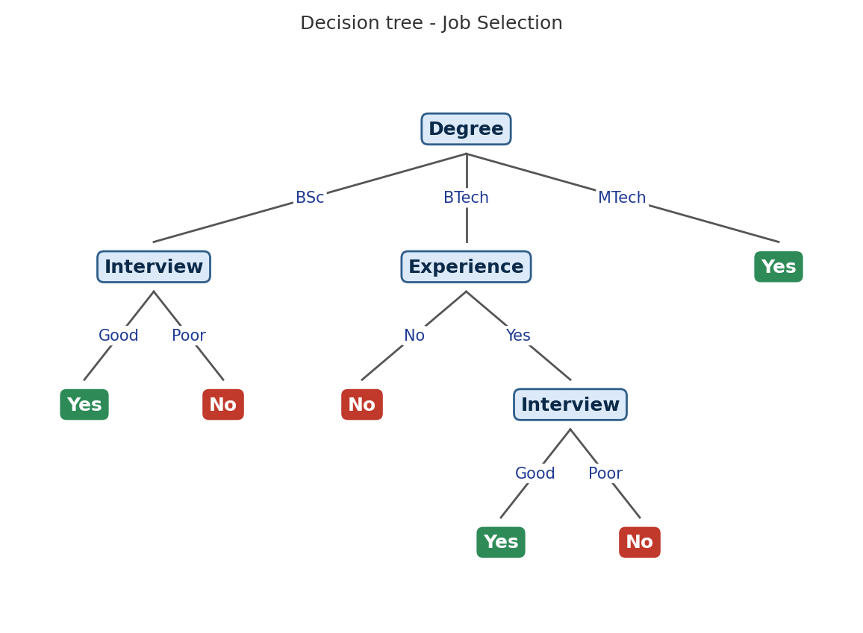

Result
ID3 was implemented with NumPy. Degree has the highest gain (0.4000) and becomes the root: MTech candidates are always selected, BSc candidates are decided by Interview, and BTech candidates by Experience and then Interview. The new candidate <MTech, No, Poor, High> is classified as Selected = Yes.

